# Responsive Web Design – Lab

## Topics Covered

*Responsive web design* (RWD) is a web design approach to make web pages render well on all screen sizes and resolutions while ensuring good usability. It is the way to design for a multi-device web. In this article, we'll help you understand some techniques that can be used to master it.

## Resources

* **Responsive design**
  + https://developer.mozilla.org/en-US/docs/Learn/CSS/CSS_layout/Responsive_Design
* **Beginner's guide to media queries**
  + <https://developer.mozilla.org/en-US/docs/Learn/CSS/CSS_layout/Media_queries>

## Tasks

### Media Types

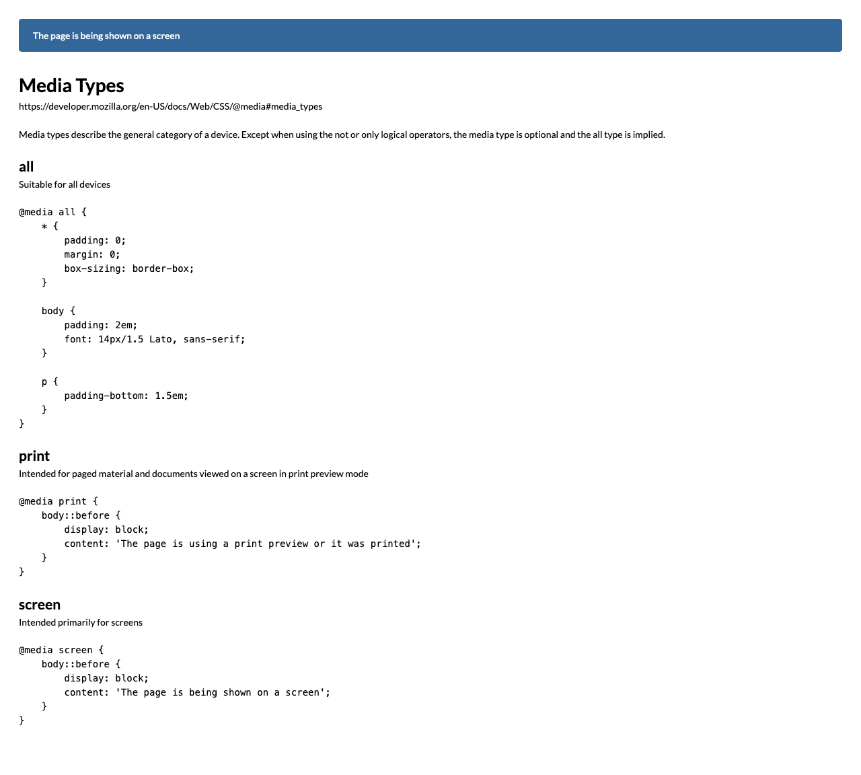

*For full screenshot check the screenshot.png file in the folder for the task*

#### Objective:

Create a webpage that looks like the screenshot above.

#### Requirements:

1. **File Setup**:
   * Create an **HTML** document named **media-types.html**
   * Create a **CSS** file named **media-types.css**
2. **Element creation**
   * Add title of the page in an **<h1>** element
   * Add **<h2>** elements and p elements for each **<h2>** as shown on the screenshot
3. **Styling**
   * Add the standard reset styling – padding, margin, box-sizing
   * Add the following styles the body element:
     1. Padding – 2em
     2. Font – 14px/1.5 Lato, sans-serif
   * Add padding-bottom of 1.5em to all paragraphs
   * Add the following styles to the body’s ::before pseudo element
     1. Background-color - #369
     2. Color - #fff
     3. Padding – 1em 1.5em
     4. Margin-bottom – 2em
     5. Border-radius – 0.3em
   * Add the media queries outlined in the text and screenshot

### Media Features

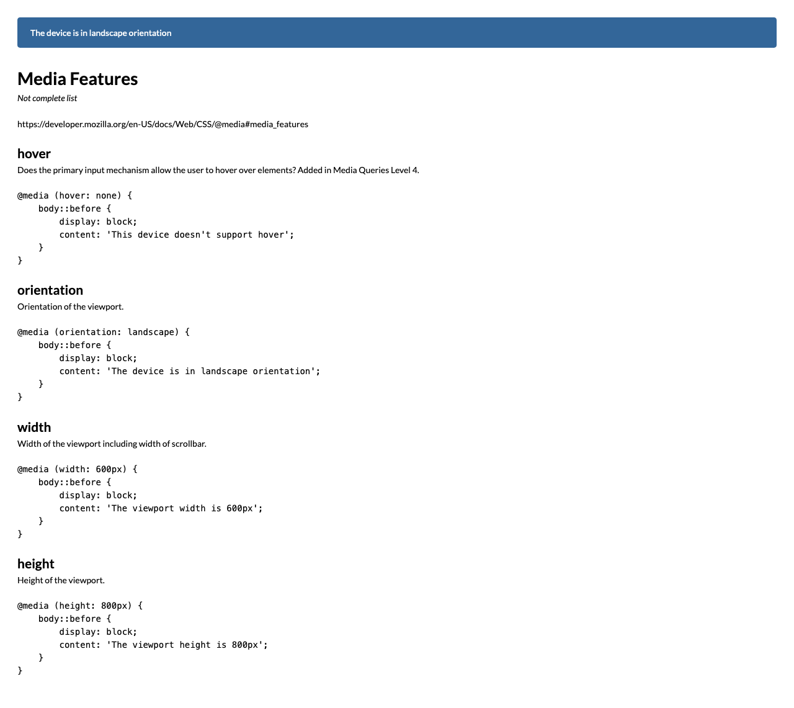

*For full screenshot check the screenshot.png file in the folder for the task*

#### Objective:

Create a webpage that looks like the screenshot above.

#### Requirements:

1. **File Setup**:
   * Create an **HTML** document named **media-features.html**
   * Create a **CSS** file named **media-features.css**
2. **Element creation**
   * Add title of the page in an **<h1>** element
   * Add **<h2>** elements and p elements for each **<h2>** as shown on the screenshot
3. **Styling**
   * Copy styling from Task 1
   * Add the media queries outlined in the text and screenshot

### Logical Operators

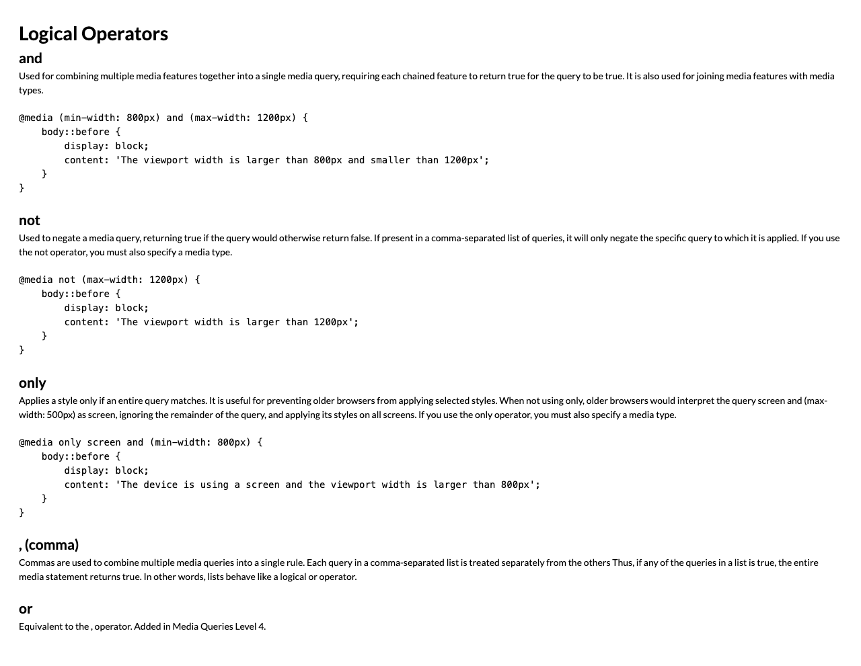

*For full screenshot check the screenshot.png file in the folder for the task*

#### Objective:

Create a webpage that looks like the screenshot above.

#### Requirements:

1. **File Setup**:
   * Create an **HTML** document named **logical-operators.html**
   * Create a **CSS** file named **logical-operators.css**
2. **Element creation**
   * Add title of the page in an **<h1>** element
   * Add **<h2>** elements and p elements for each **<h2>** as shown on the screenshot
3. **Styling**
   * Copy styling from Task 1
   * Add the media queries outlined in the text and screenshot

### Media Feature – width

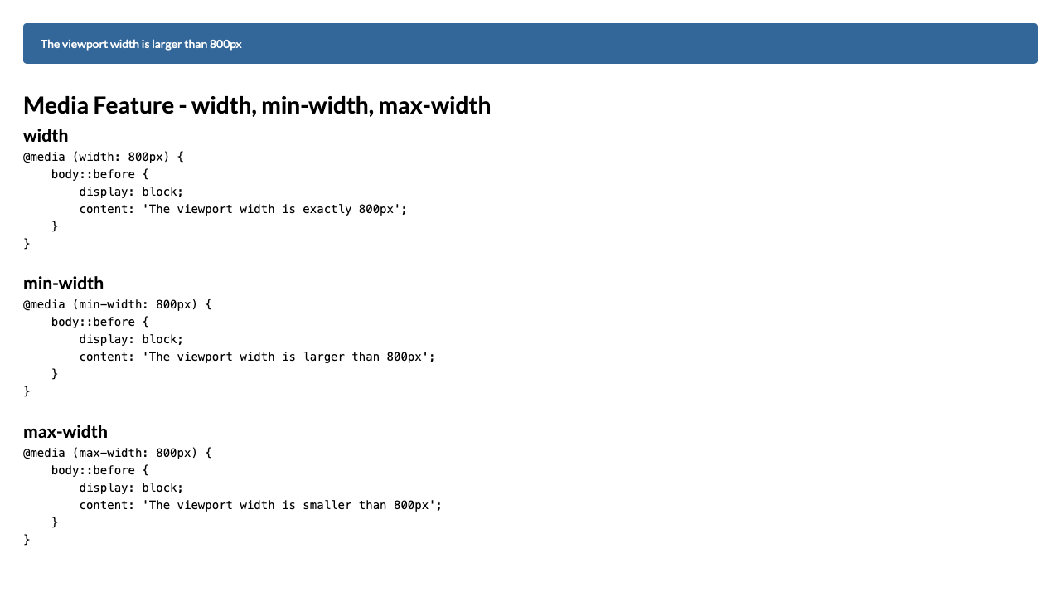

*For full screenshot check the screenshot.png file in the folder for the task*

#### Objective:

Create a webpage that looks like the screenshot above.

#### Requirements:

1. **File Setup**:
   * Create an **HTML** document named **media-****feature-width.html**
   * Create a **CSS** file named **media-feature-width.css**
2. **Element creation**
   * Add title of the page in an **<h1>** element
   * Add **<h2>** elements and p elements for each **<h2>** as shown on the screenshot
3. **Styling**
   * Copy styling from Task 1
   * Add the media queries outlined in the text and screenshot

### Media Feature – hover

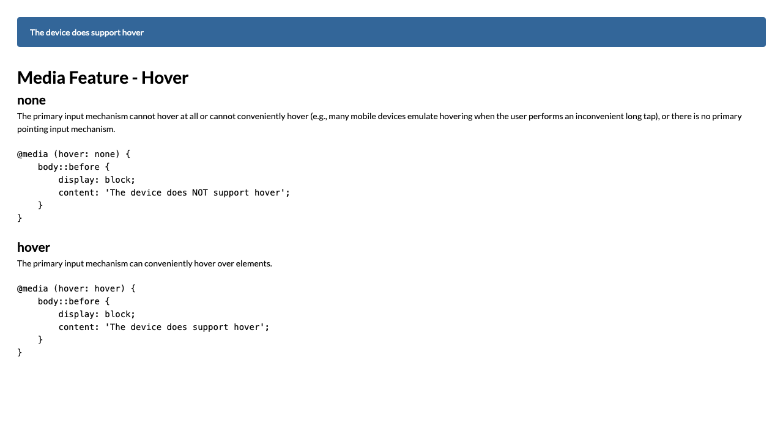

*For full screenshot check the screenshot.png file in the folder for the task*

#### Objective:

Create a webpage that looks like the screenshot above.

#### Requirements:

1. **File Setup**:
   * Create an **HTML** document named **media-feature-hover.html**
   * Create a **CSS** file named **media-feature-hover.css**
2. **Element creation**
   * Add title of the page in an **<h1>** element
   * Add **<h2>** elements and p elements for each **<h2>** as shown on the screenshot
3. **Styling**
   * Copy styling from Task 1
   * Add the media queries outlined in the text and screenshot

### Complex Queries

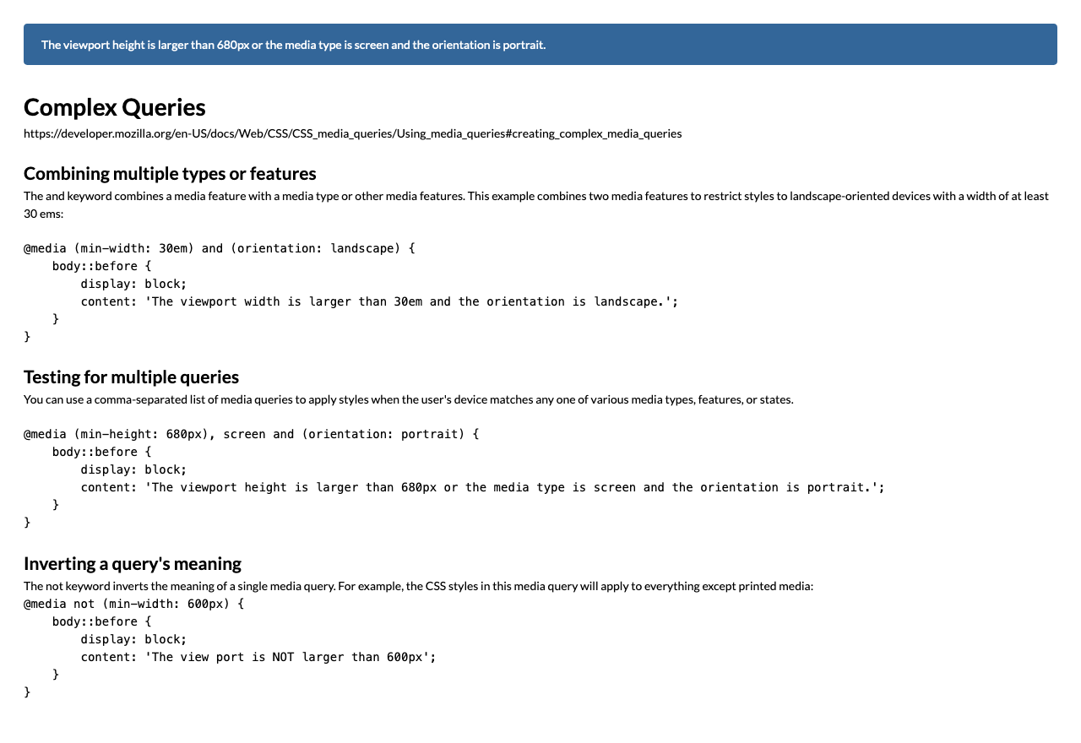

*For full screenshot check the screenshot.png file in the folder for the task*

#### Objective:

Create a webpage that looks like the screenshot above.

#### Requirements:

1. **File Setup**:
   * Create an **HTML** document named **complex-queries.html**
   * Create a **CSS** file named **complex-queries.css**
2. **Element creation**
   * Add title of the page in an **<h1>** element
   * Add **<h2>** elements and p elements for each **<h2>** as shown on the screenshot
3. **Styling**
   * Copy styling from Task 1
   * Add the media queries outlined in the text and screenshot